Nicholas Marshall

Dr. St. Clair

ITEC 4344 – Ethical Hacking

August 25, 2018

Lab 1

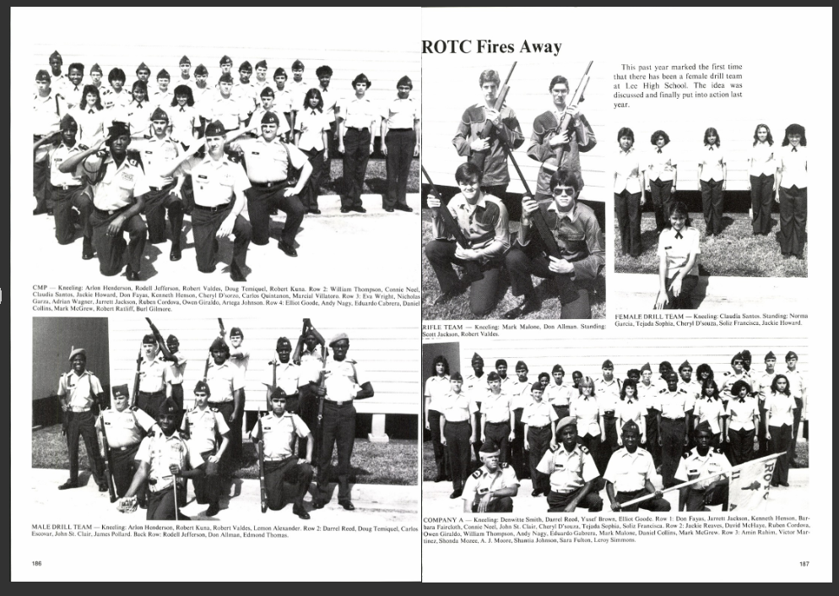

Photo of Denwitte St. Clair

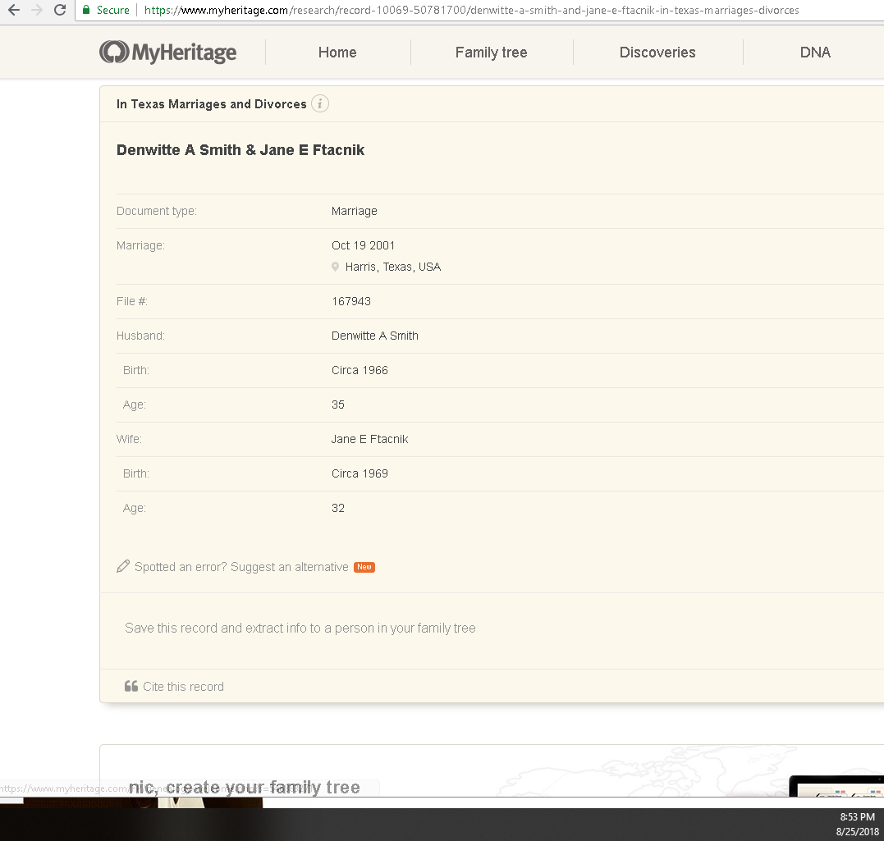

Record of Marriage

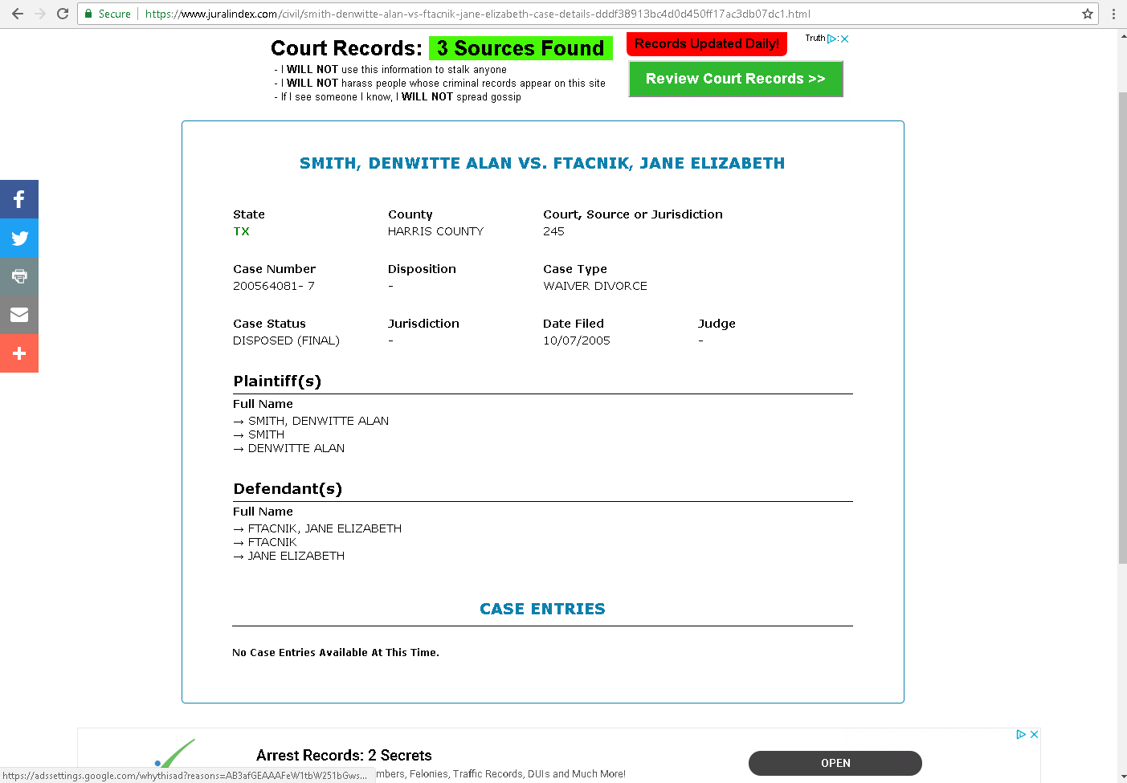

Divorce Record

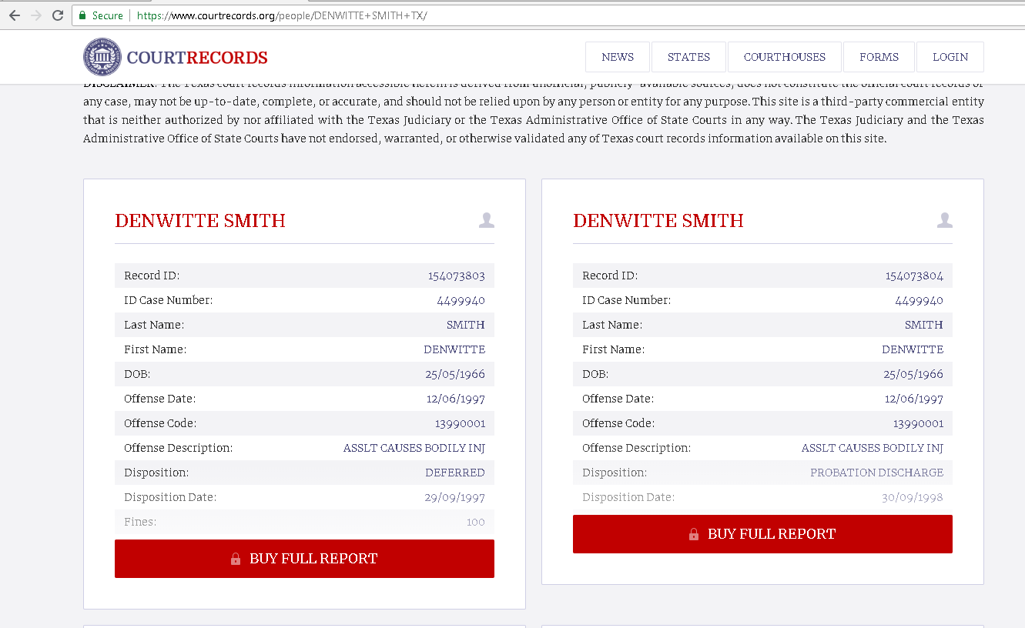

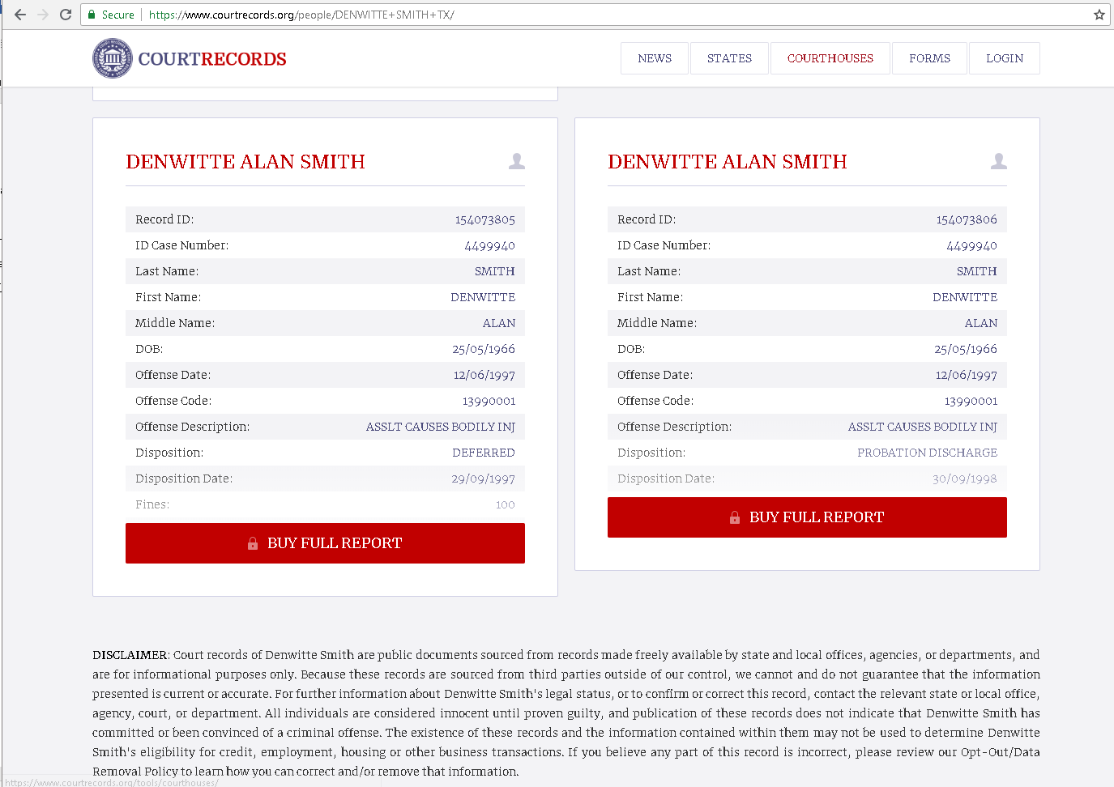

Court Records for Mr. Smith.